**Other comments on final version graphs: Maps**

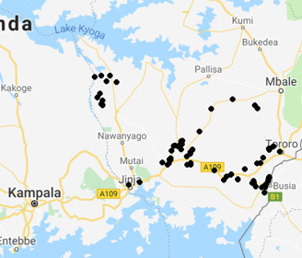

**Can you make one map which shows the above details, but hen better quality than this one?**

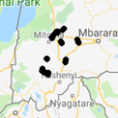

**Can you prepare one map which shows details of Western, like this map but better quality?**

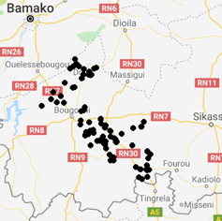

**Can you please also prepare one detailed map of Mali sample where it shows Bamako and the borders with Côte d’Ivoire?**